* **Name of the Activity:** International Conference on Quest for Bengali Identity: Present Perspective
* **Date of the Activity:** 03.06.2022
* **Name of the Speakers:** 
  + Dr. Pabitra Sarkar, Ex VC, Rabindra bharati University,
  + Dr. Rafiq Ulla Khan, VC, Sheikh Hasina University, Bangladesh,
  + Dr. Amitabha Chakraborty, General Secretary, International Society of Bengal Studies,
  + Dr. Sucharita Bandopadhyay, Professor, Calcutta University,
  + Dr.Babul Biswas, Eminent Theatre, Researcher and Secretary General, Bangladesh Theatre Archives,
  + Jaynab Bine Hossain, Assistant Professor of Sheikh Mujibar Rahaman Science and Technology University
* **Number of Participants:** 13
* Organizing Department: Dept. of Bengali, Chakdaha College, and International society of Bengali Studies
* **Photograph of the Event:**

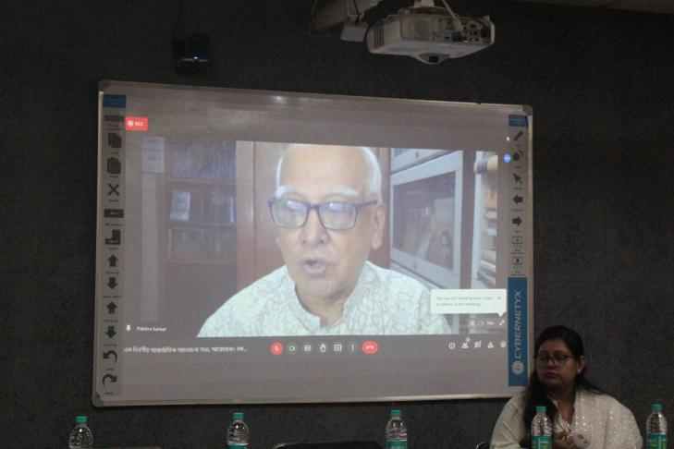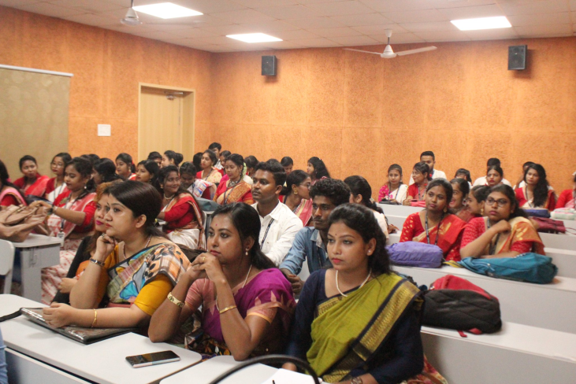

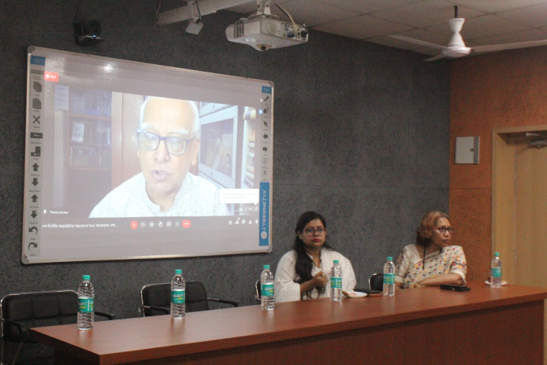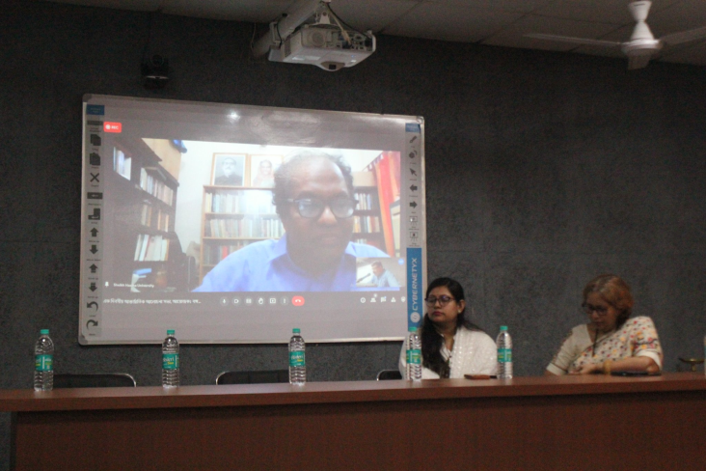

Attendance:

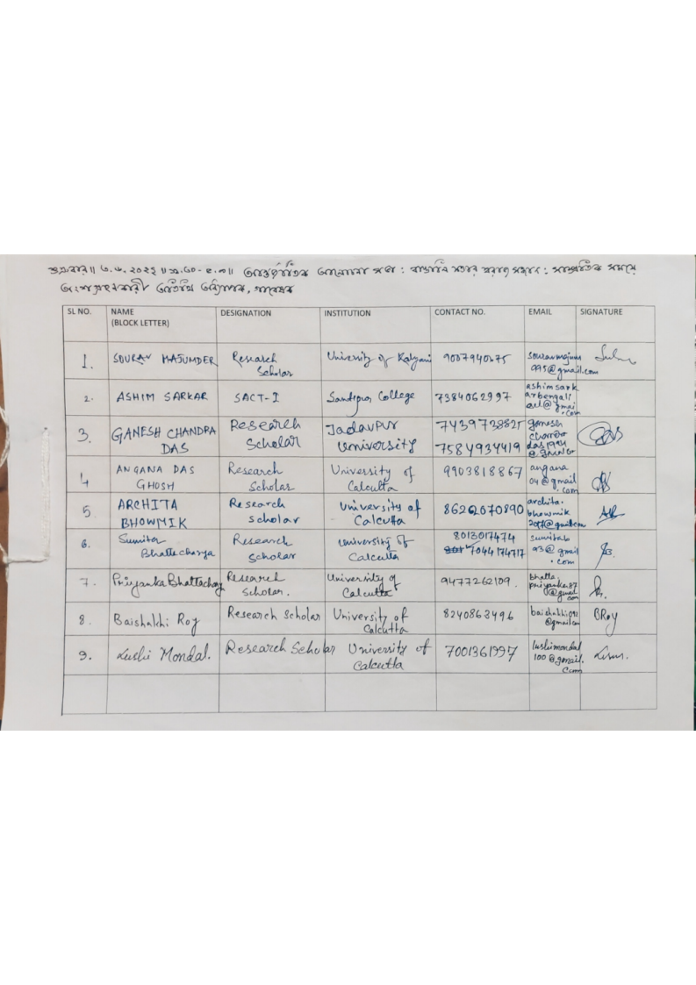

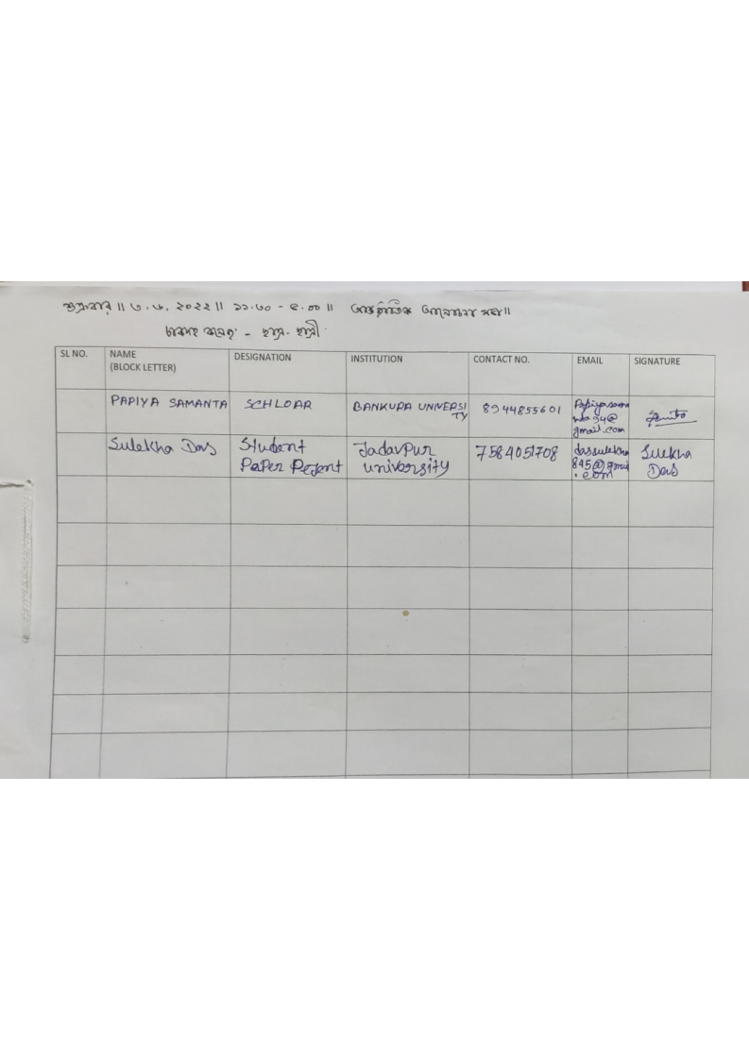

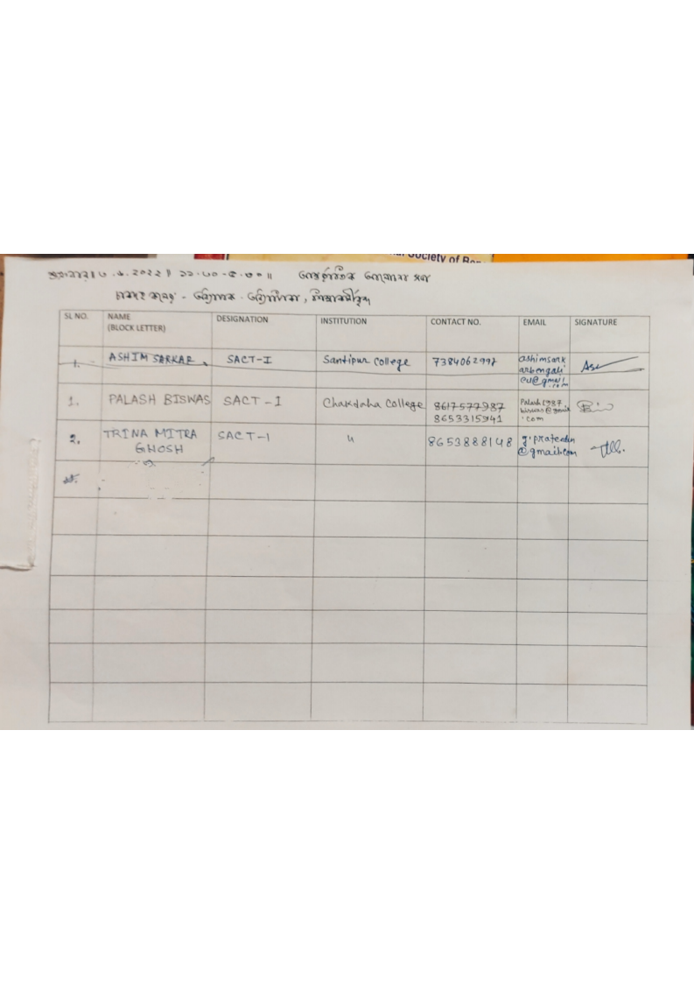

*Relevant Web Link:*

[*https://www.facebook.com/photo/?fbid=528452112348756&set=pcb.528462319014402*](https://www.facebook.com/photo/?fbid=528452112348756&set=pcb.528462319014402)